**IR Sensor**

**Introduction**

The IR sensor module consists mainly of the IR Transmitter and Receiver, Op-amp, Variable Resistor (Trimmer pot), output LED along with few resistors.

There is an IR Emitter LED and an IR Receiver (photodiode). As you can see, the sensor has 3 pins (VCC, GND and OUT). The OUT pin gives a LOW signal when the there is an obstacle which acts as a reflecting surface, and the light from the LED is reflected back to the received.

Using the property of the OUT pin (LOW when obstacle is detected), we can program our Arduino to determine if an object is nearby.

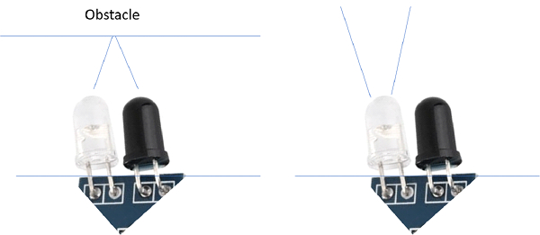

**Working of IR Sensor**

This circuit comprises the following components:

* LM358 IC 2 IR transmitter and receiver pair
* Resistors of the range of kilo-ohms.
* Variable resistors.
* LED (Light Emitting Diode).

the transmitter section includes an IR sensor, which transmits continuous IR rays to be received by an IR receiver module. An IR output terminal of the receiver varies depending upon its receiving of IR rays. Since this variation cannot be analysed as such, therefore this output can be fed to a comparator circuit. Here an operational amplifier (op-amp) of LM 339 is used as a comparator circuit.

‘

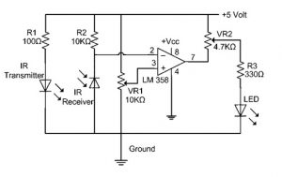

When the IR receiver does not receive a signal, the potential at the inverting input goes higher than that non-inverting input of the comparator IC (LM339). Thus, the output of the comparator goes low, but the LED does not glow. When the IR receiver module receives a signal to the potential at the inverting input goes low. Thus, the output of the comparator (LM 339) goes high and the LED starts glowing.

**Pinout of IR Sensor**

